“Smart Mouse” Tracking Performance Report

19 June 2010–06–19

**Introduction**

The aim of this report is to quantify the current performance level of the mouse tracking software.

**Ground Truth Labeling Procedure**

A five day sequence was selected (Feb 28 2009). Since it was not feasible to go over every frame of the data, it was decided to test only a subset, which is supposed to be representative. The subset contains frames from the first, third and fifth day. Four hours were selected at random from each day (see table 1). Three hours from the dark cycle and one hour from the light cycle. Mice were on a reversed cycle. Lights turned off at 10:00 and back on at 22:00.

To reduce the manual labor further, only a single frame every 150 frames was actually labeled. This corresponds to checking the tracking results every 5 seconds within the hour.

Table 1: Subset of the 5 day sequence used in the ground truth procedure.

|  |  |  |  |  |
| --- | --- | --- | --- | --- |
| Day | First Hour | Second Hour | Third Hour | Forth Four |
| 1 | 12:00-13:00 | 15:00-16:00 | 20:00-21:00 | 01:00-02:00 |
| 3 | 13:00-14:00 | 14:00-15:00 | 19:00-20:00 | 04:00-05:00 |
| 5 | 17:00-18:00 | 19:00-20:00 | 20:00-21:00 | 05:00-06:00 |

To reduce possible bias from the human labeler, frames were shuffled and tracking results were displayed without the identities decided by the automatic algorithm. Thus, in each frame, the human labeler saw four ellipses, colored uniformly (magenta). The small image patch centered at each ellipse was magnified at displayed on the right of the screen. The task of the human labeler was to match the small image patch to image patches representing the true identities (i.e., these images were fixed throughout the entire ground truth procedure). The fixed image patches were selected from the classifier training sequence and display the characteristic markings. The human labeler had initial training and saw several examples of each identity, so the fixed images served just as a reminder. A snapshot from the ground truth application is shown in figure 1. The human labeler matched the set of magnified images by clicking the small color rectangles below each image.

Annotators were instructed to first evaluate segmentation (assigment by SmartMouse of positions of mice).  If segmentation was correct, the annotator was then instructed to assign identities “to the best of your ability”.  If the annotator could assign three identities with high confidence, they were allowed to mark the fourth ID by process of elimination.  Annotators were instructed not to guess, but to assign IDs if they were reasonably confident.  The annotator was not required to mark identity of all four mice on each frame—partial marking was allowed.  If segmentation was incorrect the frame was marked “Segmentation Incorrect” and the annotator moved on to the next frame.

Figure 1 **–** Snapshot from the ground truth appliation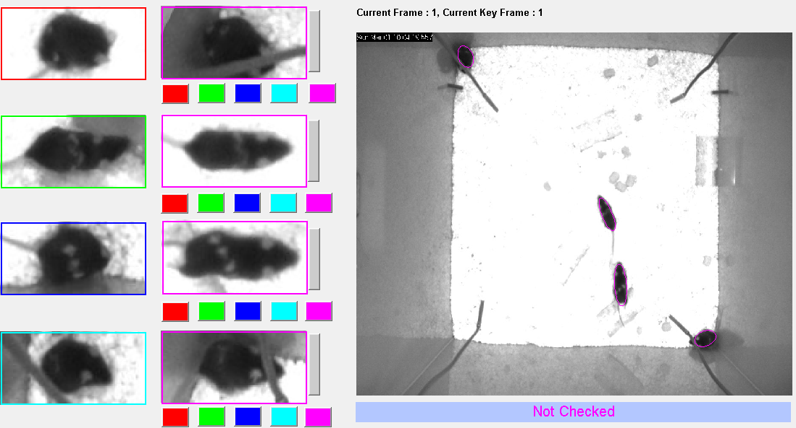

**Definitions**

1. “Fully Annotated Frame” – a frame in which the human labeler annotated all mice. In the rare cases in which the human labeler forgot to mark all mice the frame will be denoted “Partially annotated”
2. “Failed Segmentation” – a frame in which the human labeler decided that tracking output does not accurately portray mice position. A single mice that was not accurately segmented will cause the entire frame to be declared as failed segmentation.
3. “Incorrect” – A key frame with at least one identity swap
4. “Correct” – A key frame where all identities are correct

**Results**

For some reason, the last hour has extremely poor results. Further investigation is needed to understand exactly why.

When excluding the last hour, the final statistics are:

**7838** Frames (10.89 hours) were checked (fully annotated)

**113** (**1.44 %)** Frames were labeled as Failed Segmentation

The statistics for the remaining 7725 Frames:

6602 (**85.46 %**) were marked as Correct

1123 Incorrect frames (**14.54 %)**

Out of which, **338** **(30%)** were when all mice were close together

**40.87**% of the incorrect key frames occurred when the flipped identity was near one of the microphones.

The 1123 incorrect frames can be further decomposed into:

**2** Identity Swaps : 935 (**83.26 %)**

**3** Identity Swaps : 140 (**12.47 %)**

**4** Identity Swaps : 36 (**3.21 %)**

The correct percentages per hour are:

|  |  |  |  |  |
| --- | --- | --- | --- | --- |
| Day | First Hour | Second Hour | Third Hour | Forth Four |
| 1 | 78.36% | 97.94% | 77.25% | 68.79% |
| 3 | 69.94% | 90.43% | 97.23% | 90.54% |
| 5 | 76.58% | 81.78% | 96.39% | Excluded |

**How accurate are the annotator labels?**

Took me couple of hours, but I have selected at random 100 correct key frames and 100 incorrect key frames and checked each one of them to see whether the annotator label was correct or not.

|  |  |  |
| --- | --- | --- |
|  | Verified as correct | Verified as incorrect |
| Correct Key frames  (by annotator) | 96  4 Can be labeled either as “Failed Segmentation” or as “Correct”. One ellipse was slightly off, but identities were correct. Below is an example | 0 |
| Incorrect key frames  (by annotator) | 2 – Labeler was wrong | 96  2 – Can either be considered as wrong incorrect or should have been given “Failed Segmentation” |

**Can we predict the correctness of a keyframe using classifiers confidence?**

The log likelihood of each key frame was computed. It does seem like the correct frames are skewed to the right, but there is no clear cut threshold to differentiate between the two distributions. Furthermore, it seems that the correct key frame distribution has a long tail.

